AINT253 – Design Process – User testing documentation

Outline of goals for user testing

• Prototyping and testing scenes/builds

• Data collected from surveys, interviews, observations etc.

• Data collected from any analytics within your unity projects

• Synthesis of data collected to inform direction of development

Outline of goals for user testing:

For my first batch of user testing, I first needed to get my Towers of Hanoi puzzle tested. This is because it was the most frustrating to program, mainly because every combination had to be coded manually. I also wanted to know how difficult people thought it was, on a scale of 1-10.  
The outline of the main points of the testing are below:

* Ensure that the puzzle was easy to understand.
* If the player experienced any combinations that did not work, I asked them to record it.
* I asked the player what rating they gave my puzzle for difficulty, scale of 1-10.
* Ensure that the puzzle was not too annoying to the player.

For my second batch of user testing, I wanted to get some more feedback on the towers puzzle (I had updated it at this point, but was still unsure whether it was working properly as my own testing found very little errors, but I needed a bigger pool of participants).  
The outline of the main points of my second batch of user testing is below:

* Get feedback on how my Towers of Hanoi puzzle felt to use and play around with. I also asked if they still found any combinations that did not work.
* Ask the player how they felt about my overall lighting effects.
* Ask the player for suggestions on how my game could be improved.

For my final batch of user testing, I wanted to get some feedback on my overall game. By this point, I have completed the entire game, both puzzles included and wanted to know how the game flowed, as well as feedback on audio and visual interaction.  
The outline of the main points of my final batch of user testing is below:

* How did the audio and visuals feel? Does it fit the theme?
* Did you encounter any bugs with the game that made a difference to how it felt?

My overall user experience that I wanted the user to have is the following:

* An immersive visual and audio experience throughout, trying to keep it quite consistent.
* A feeling of tension as a timer counts down while the user is working through the escape room.
* Feel like they are in control as much as possible.

Prototyping and testing scenes/builds

Whenever I created a new piece of code, or a new asset, I would create a save and then run it within Unity.  
For example, when I was creating the wall asset, I created multiple iterations of it which I will show below:

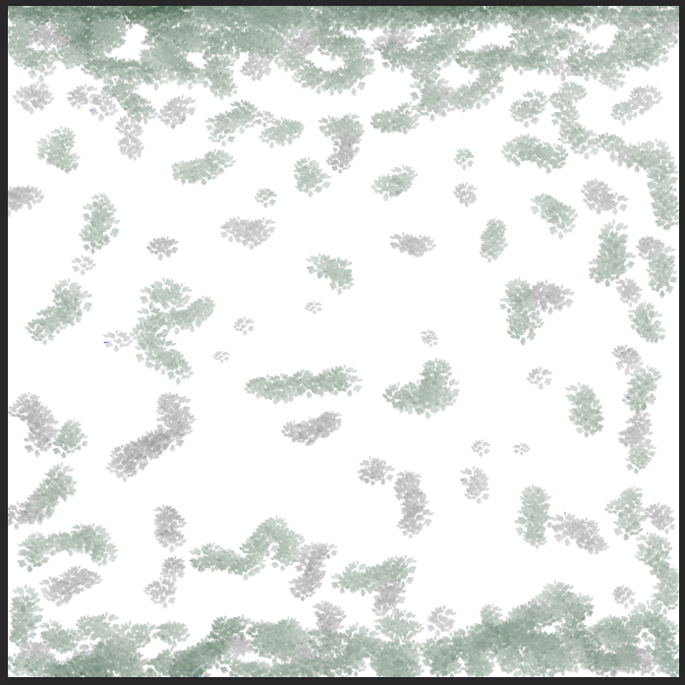

Before the second test, I wanted to have an idea of what sorts of walls I could create within Photoshop. As the theming is around Fallout/Post-apocalyptic, I wanted to go for a mouldy look, as this is usually what happens when there has been a lot of dilapidation.

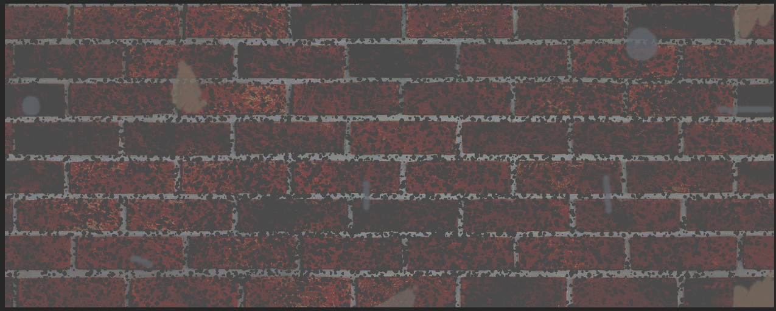

This was one of the first wall prototypes that I created. This was intended to see how it would fit (as the asset is continuous) however when I applied it to Unity, it was very obvious that it was repeated.

I then decided I would try and create a “long wall” asset for one of the large walls on the back of my escape room:

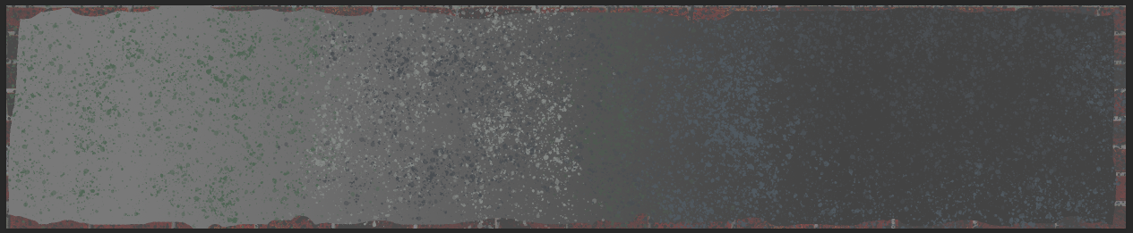

I eventually realised that this looks better, as it looks as if the outside is crumbling away, and that it would be quite suitable. I also decided for another large wall that I’d create a different style of wall:

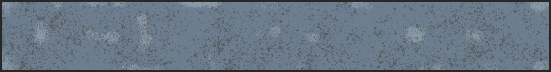

I decided I would change the colour a little bit from the greys and browns that I have originally been using, to go for a slightly lighter blue colour. This was to differentiate the wall as it was the wall at the furthest back. I have kept this wall within my escape room, on the furthest wall back. As the texture is so large, it fits the entire length of the back wall. 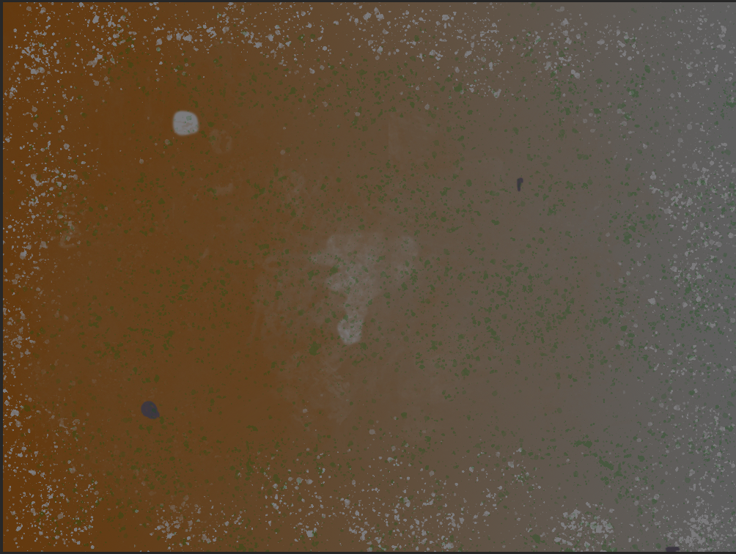

This was another one of my prototype textures for my wall. I am not using it in my final build however.

Data from surveys:

I have two main surveys that I obtained data from. The first one was done in a build where there the towers of Hanoi puzzle was in it’s simplest form. I asked the participants the following questions:

* Do you have any general feedback for my puzzle?
* Did you find a valid move that was flagged as invalid? Try and be as specific as possible if you can!
* How challenging do you think the puzzle is?
* How was the lighting effects?
* Did you encounter any other bugs other than the ones listed on the notepad document? If so, try and be as specific as possible.
* Was the puzzle easy to understand?
* Were there any hitboxes on some of the poles that did not work?

From this, I was able to gauge the following goals:

* Ensure that the puzzle was easy to understand.
* If the player experienced any combinations that did not work, I asked them to record it.
* I asked the player what rating they gave my puzzle for difficulty, scale of 1-10.
* Ensure that the puzzle was not too annoying to the player.

For the first goal of this test, I managed to get some pretty good feedback. At this point in the build, I was not expecting the puzzle to be that understandable, as I had not programmed in any of the instructions other than on a simple text document that was provided to the user:  
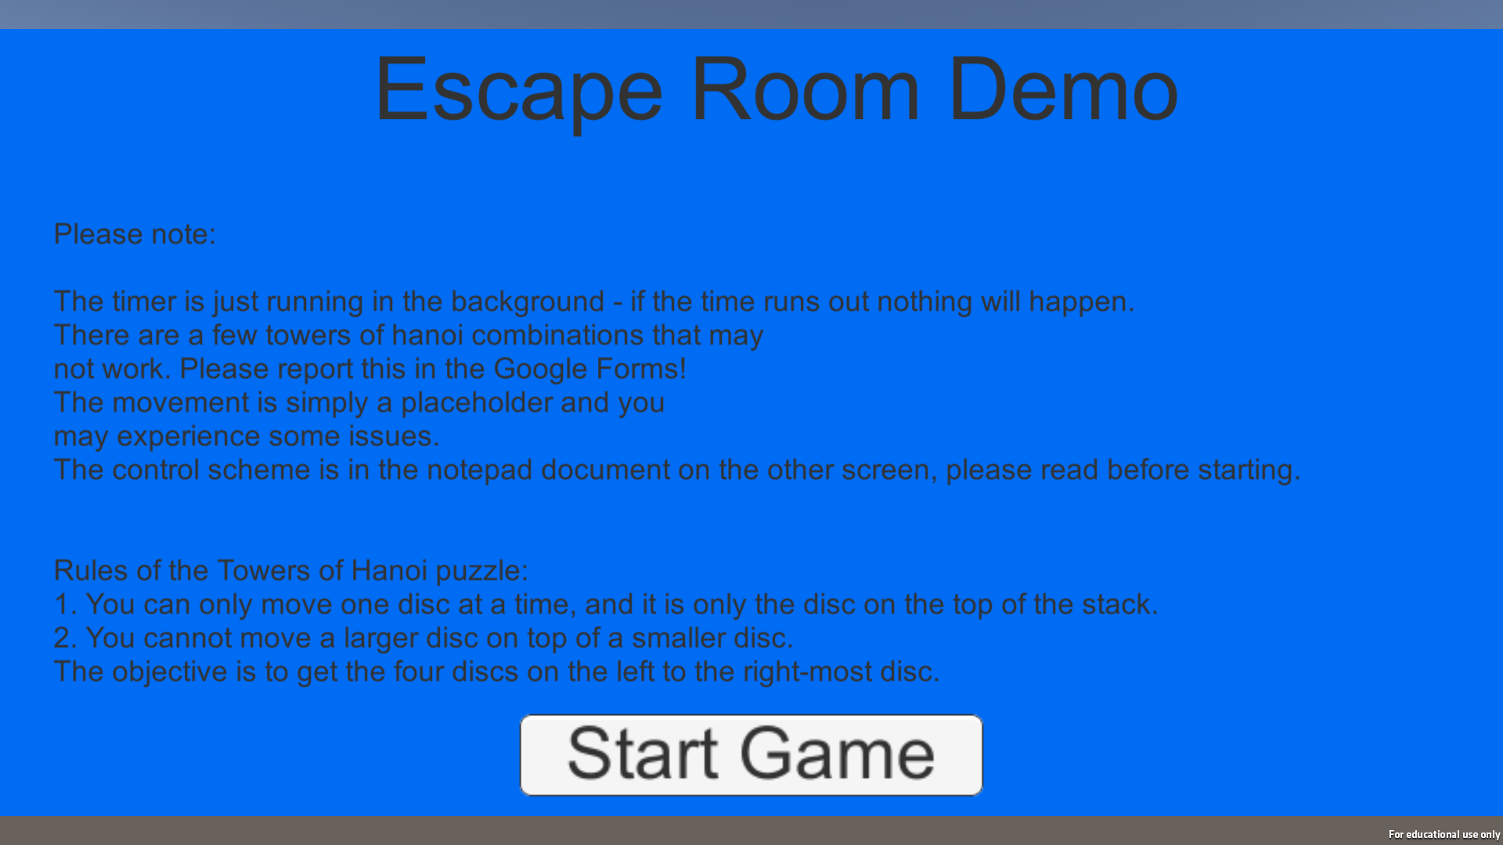

I expected some people might miss this and then get confused. However, out of the 8 participants, only one person did not understand it, but after they read the instructions for a little bit they were able to work out how it worked. I took this as my first goal was successful.

For the second goal of this test, I wanted to know which combinations didn’t work. The reason for this is that during my own testing, I am quite biased in how I tested it, since I knew the solution, so as a bare minimum I had coded the most efficient way to complete the puzzle and a few other combinations, but not every combination.

The feedback I received is as follows:

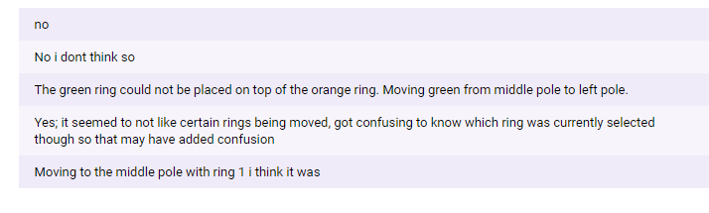

With this data, I was able to fix a few combinations, although this didn’t really accomplish the goal that I wanted. I hoped people would have put the actual combination they got such as “moving 3 stack of second/third/fourth to a separate pole deleted the second element”. I ended up having to do internal testing and writing down each combination that I found wasn’t working, and then programming them in individually, and then completing a second test.

For the third goal of this test, I requested the participant to give the challenge rating of my Towers puzzle on a scale of 1 to 10, with 1 being very easy, and 10 being too difficult. I wanted to get around 5-8 mark, as everyone is different so some people will find it much easier than others.

The marks that people gave were as follows:

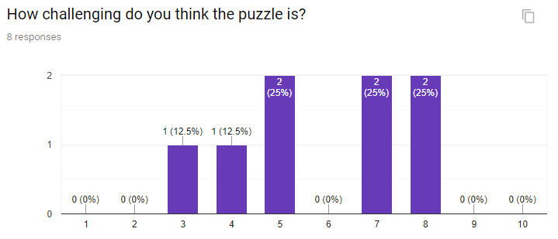

Overall, I believe that the towers puzzle is about as difficult as I can make it. I did consider adding in another block to make it a five ring puzzle, however this would take far too long development wise, and make the game potentially impossible to complete for some people.

For the final goal in this test, I wanted to see whether people found my puzzle interactable or not. I have coded special hitboxes in front of each of the objects for the back end to determine which object it is. I asked the user to see if any of these hitboxes didn’t work:  
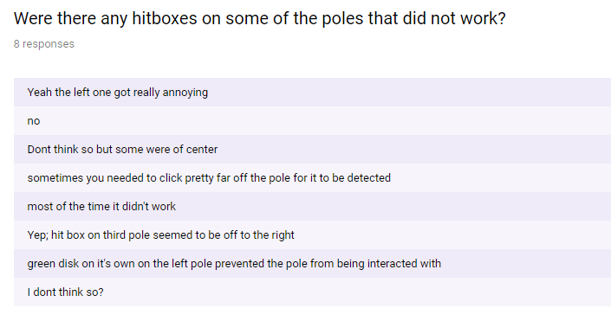

From this I gauged that the hitboxes were quite janky, and I went back to my unity project to review them. I discovered that a few of them were a little bit broken, and I corrected it.  
I also discovered that there was an issue with the clicking. I was using fixedupdate within the script instead of update to reduce CPU load, however it made it much harder to click. I have now updated it in the script to reflect this:

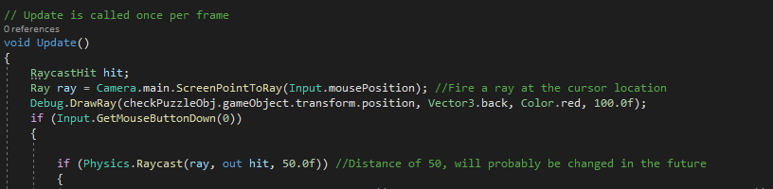

Overall, I found that this goal was met. I discovered that not everyone got on with the way it was originally, and I managed to update the code to make it more consistent. I also reviewed all of the hitboxes and made them more consistent.

In consideration of all of the tests that I completed, I am happy with the results, and am happy to keep the puzzle in the game in the current state (although completely fixed with better clicking etc).

For my second test, I decided to get a little bit more feedback on my new revision of my towers puzzle, as well as some feedback on lighting. The questions that I asked this time were a little bit different:

* Did you manage to complete the puzzle successfully?
* Were there any issues with my puzzle?
* How was the lighting on a scale of 1-10?
* I'm going to make it post-apocalyptic themed, what extra decorations should I add to enhance the feeling of it?
* Any other general feedback?
* Do you like the font used for the UI elements? If not, what would you change?

The goals that I wished to establish this time were:

* Get feedback on how my Towers of Hanoi puzzle felt to use and play around with. I also asked if they still found any combinations that did not work.
* Ask the player how they felt about my overall lighting effects.
* Ask the player for suggestions on how my game could be improved.

For the first goal of the test, I wanted to review my towers of Hanoi puzzle again. The reason for this is that I had improved it between the first demo and this demo, although I wanted some other people to feedback. I asked the questions about completing the puzzle and if there are any issues with the puzzle to ensure that it works.

The feedback is as follows:

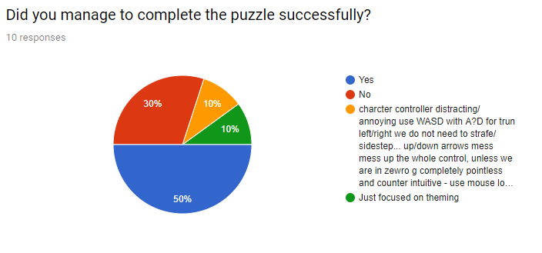

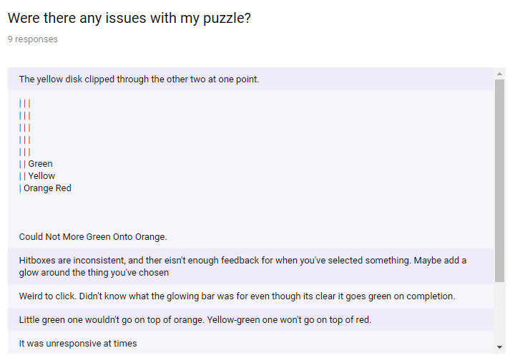

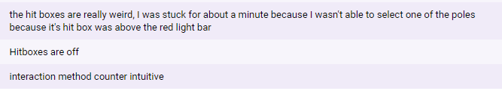

Overall the feedback I got is that 6 in 9 were able to complete the puzzle, and 1 person did not complete the puzzle as they were not focused on the puzzle. This is a good number because I believe that some people may have given up quite quickly. I also managed to get some information about my puzzle, that the hitboxes were still a little bit broken, so I tweaked it a little bit again after the demo. I feel that it met my goal of the test.

For the second goal of my test, I wanted to get some feedback on my first attempt for lighting effects. At this point, I had only created a few lights which had a flickering effect, and I wanted to see how people saw my lights. I asked on a scale of 1-10 how they felt about my lighting effect:

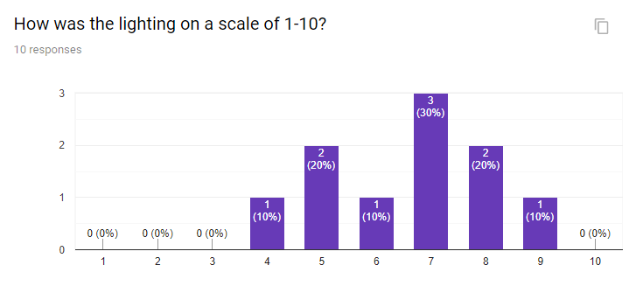

I was hoping to see that people responded positively to the lighting, otherwise I would have to change it. Overall, the ratings that I got was very positive, averaging around 7 to 8 at this point. I took this forward in development by simply enhancing the flickering effect. I also asked how people felt about the lighting in my first test, but I did tweak it from that point, as the user was able to walk in the second build.

For the final goal of my test, I just wanted to get some general feedback for the escape room. At this point, there was only movement (which I did state to the user was not working correctly) from a starting point to the end point. Overall, I just wanted to see how people would improve my escape room, and this is what I got from it:

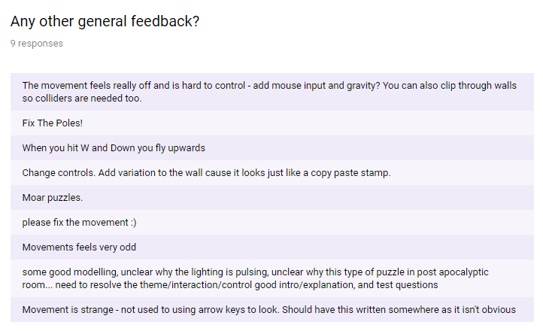

Overall, I didn’t really think that it met my goal for user testing. A lot of the feedback was about the movement, or stuff that I was already aware of. The only thing I took out of this feedback is that I needed to update the walls. I did not include more puzzles mainly because of development time, I also had little idea of what ones I wanted to make.

I finally gave the final build to a friend to test, as well as gather some feedback on my audio, and the visuals overall.

For the lighting he said:

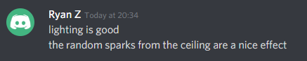

For the overall sound he said:

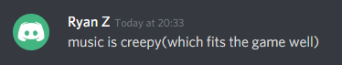

He also caught a bug that I have since fixed in the newest final build:  
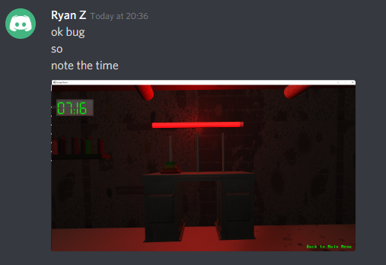

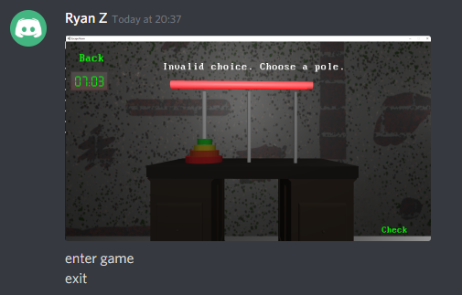

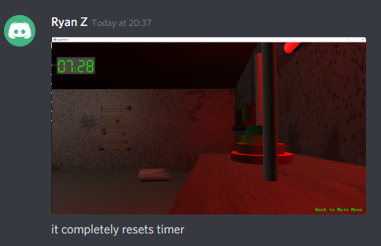

Overall based on the feedback that my friend gave me, I have made a few small tweaks as a mini-patch. I have decided to not fix the timing bug as it is minor, as I don’t expect many people will be pressing the back button – it is there so the player is not stuck, but have fixed any minor text bugs that he found such as some text being too long to fit on the screen so I have reduced it in length.

Data used to inform development:

From my second in-class user test, I asked a separate question which was not related to any of the goals of the original test. This question was to inform further development of my escape room:

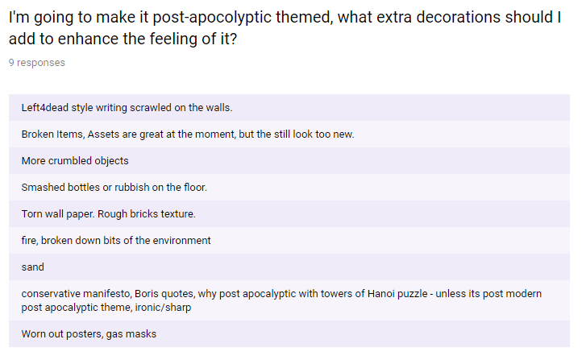

From this, I took some main points:

I needed to enhance the overall room, including stuff on the floor to make it look more dilapidated, add some more wall assets, change the walls to make it look a bit better.  
I did not include some of the feedback such as the conservative manifesto as I know that this was a joke comment, but I also did not include gas masks or the writing scrawled on the walls.

I decided to make some new wall assets. This mainly included mock safety posters:

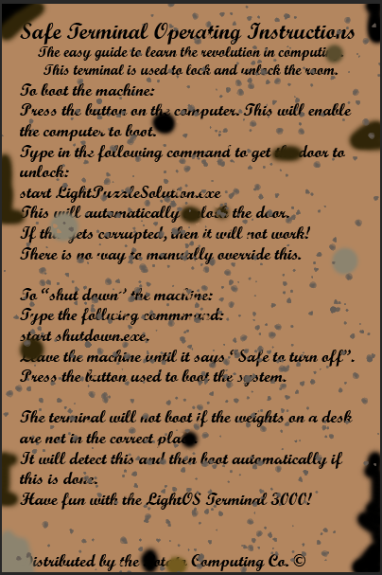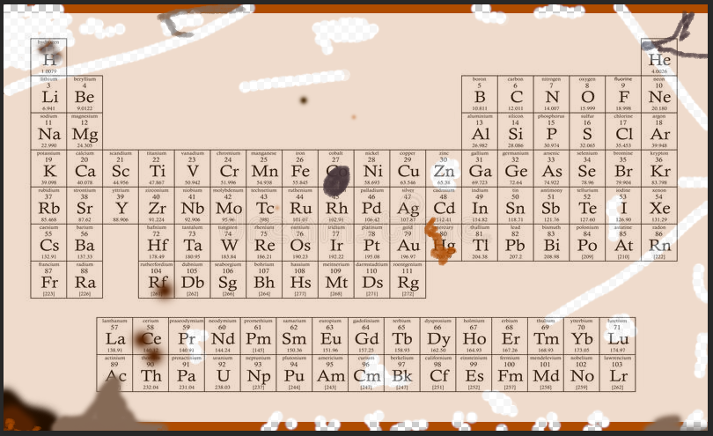

These posters are on the walls of my escape room (The periodic table image has been accredited in my build of my escape room). I also created some smashed bottles on the floor to create the effect that it has been abandoned.

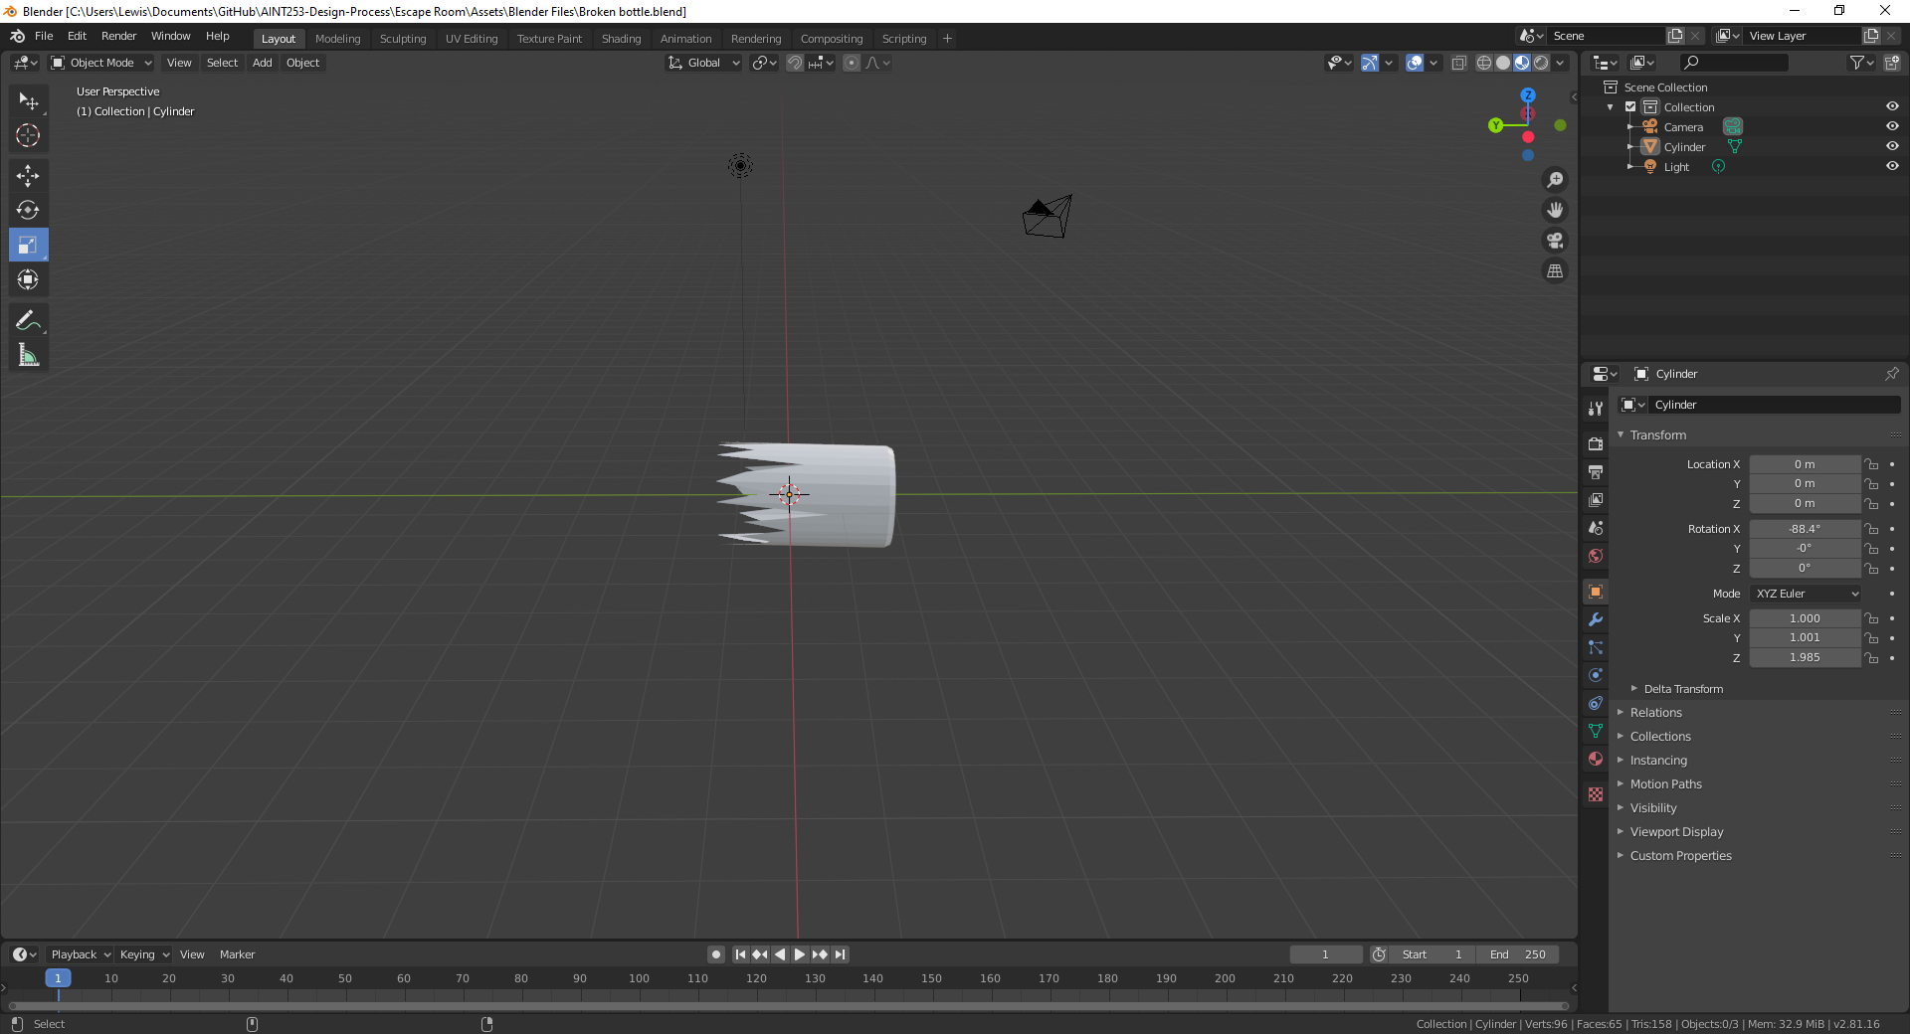

While a not direct comment, I also used this to think of some more ideas, including a dripping broken pipe and sparking particles from the ceiling. I felt that this would help to improve the overall feel of the environment.

These particle effects show that the area is breaking down. Here is an example of these particles:

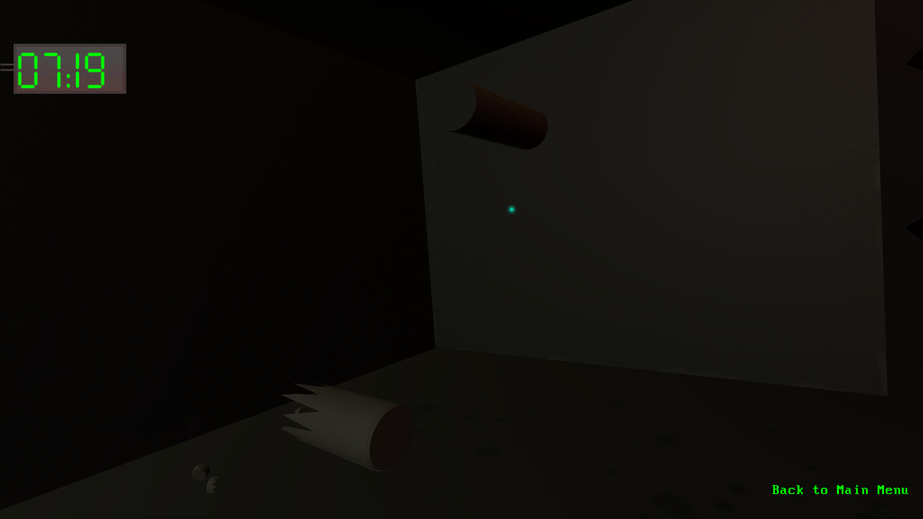

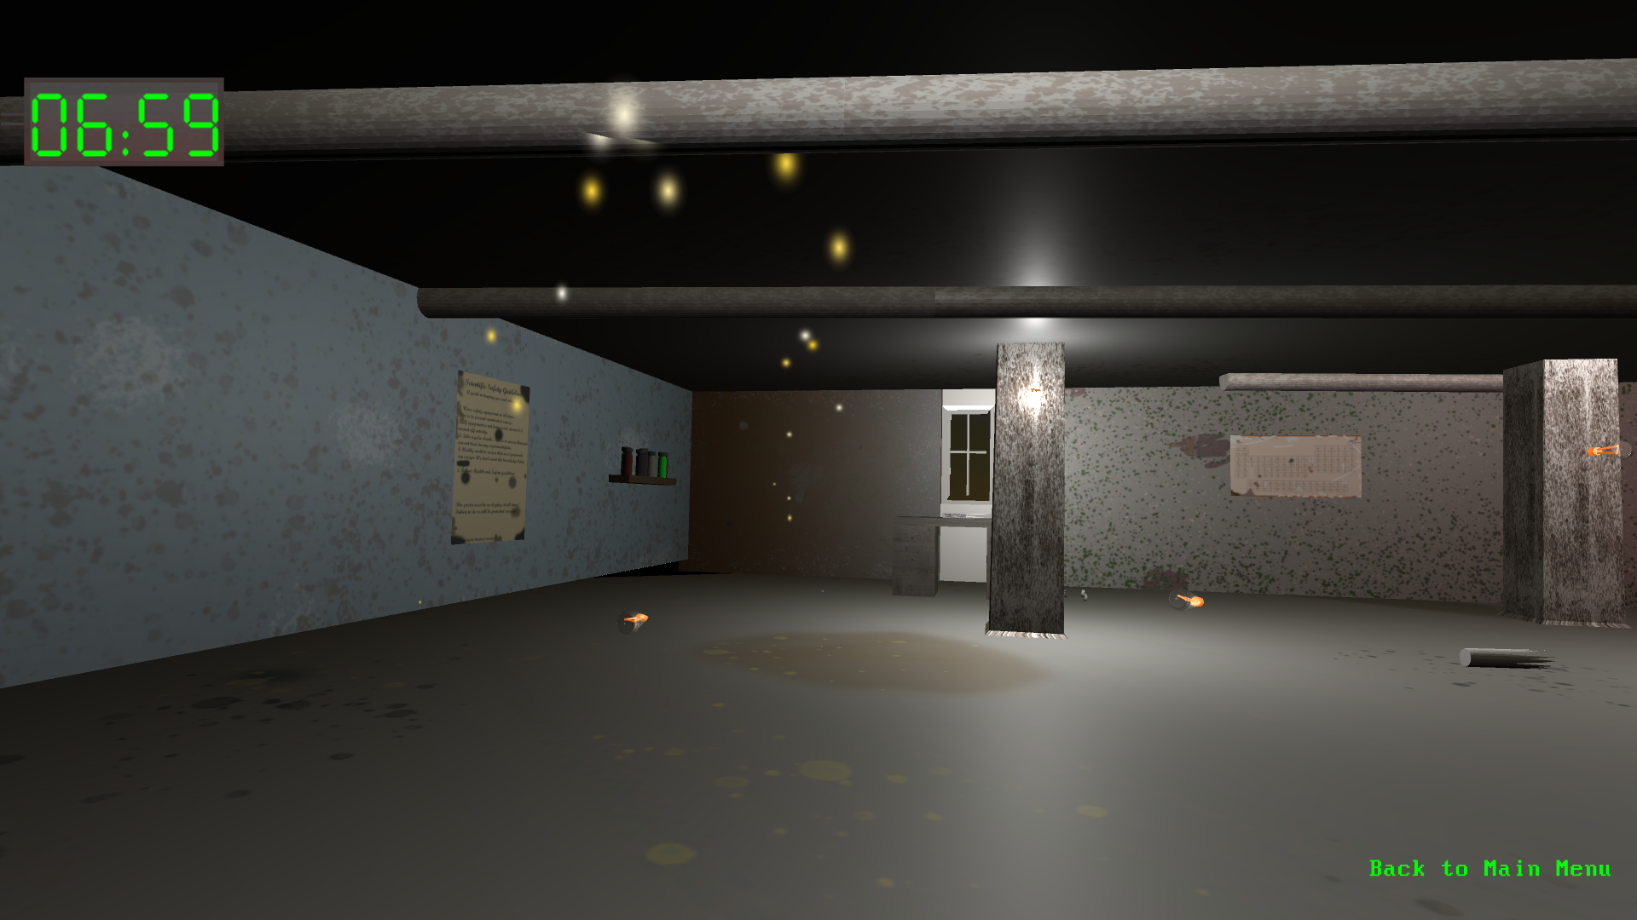

I also chose to change my wall assets to include a brick texture instead of just being a plain background, which makes it look more dilapidated. This was mainly from the feedback, and I did not think to do this originally. The wall art I have chosen is:



This art has a brick texture behind it (accredited in the build of my Escape Room).

In my first user test, I asked how people felt about the lighting effects. While this was very much a prototype at the time, most people seemed to like it generally.

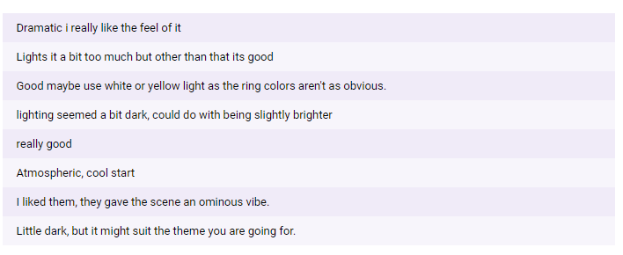

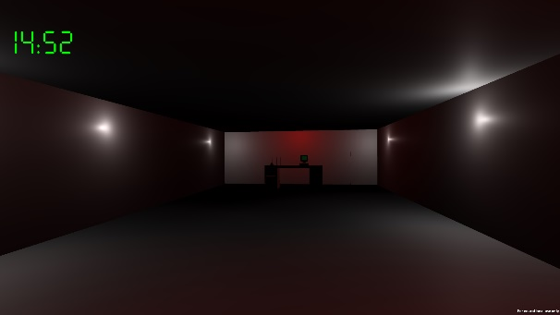From this I took the following through development:  
I kept the flickering effect of the lights, as it seemed to give the right theming overall. However, I decided to make it a little bit brighter.

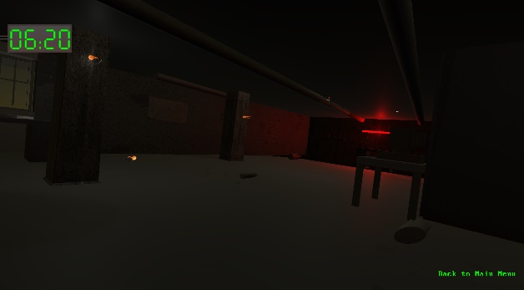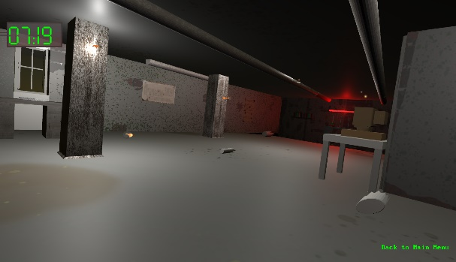

In this series of images, you can see the original lighting in my first demo build, and then a comparison of the brightest and the darkest effects in the final build. I decided to keep the white light but at the darkest points it becomes barely visible.

Some people didn’t really give much pointers other than that it looks good, which I took as a positive when it came to my lighting. I hope that with my audio additions as well as lighting tweaks, it will give a very dangerous feeling vibe to the game.